**CHAPTER 1**

**INTRODUCTION**

Health Care is web based application specially designed for fitness throw natural remedies like exercise and diet. Every system might have existing system and might don’t have. In early system people have not well known about ideal weight. As a result in future people face health problem from extra weight or less weight.

The existing system had been static.

1. People don’t know about their ideal weight according to height and age.
2. In day to day life people don’t maintain their diet as result extra weight is gained.
3. People don’t do daily exercise hence they have problem in future.

In health care we provided the health calculator for people to get their ideal weight by entering height and age. The ideal weight is calculated from miller formula. In health care people also check exercise according to their ideal weight. Here ideal weight is getting compared with entered weight. If ideal weight is less than entered weight then weight loss exercises is shown to people. If ideal weight is greater than entered weight then weight gain exercises is shown to people. With exercises the diet are show to people for weight gain or weight loss.

Also we provided information about diseases. Diseases which are commonly occur in our life. List of diseases are provided. When people want to know about diseases they select diseases and hit enter information about diseases like causes, symptoms and precaution are shown. Here we provided the facility which give location of nearby hospital. Also user can search other hospital by entering name of the hospital in search box.

**1.1 Motivation:**

In early system people face some problem due to their weight. If people know their ideal weight then they can maintain their weight and which prevent them from future health problem. Children are also facing health problem because of extra weight or less weight (malnutrition). These problems of children or people are lead to be major problem of health.

**1.2 Aim:**

The purpose of this project is to design a system which keeps people healthy. In past, people don’t know their ideal weight so we help them to find their ideal weight and proper exercise and diet according to their weight. Also give information about dieses. Give location of the nearby hospital.

**1.3 Objective:**

The Objective of the project is to develop a system that gives information to people related to exercise and diet according to their weight. The purpose is to design a system using which one can perform all operation required by the person for maintaining their health.

**CHAPTER 2**

**SYSTEM ANALYSIS**

**2.1 Problem Definition:**

* All Work are done manually.
* In Manual System Public has to go to the health center and gym.
* People don’t have time to do daily exercise.
* People don’t know the proper diet.
* People don’t know about dieses.

**2.2 Requirement Analysis:**

**2.2.1 Data Requirement:**

1. Table name**:** logininfo

Description**:** To store the user name, password and type of user.

Primary Key**:** uid

|  |  |  |  |  |
| --- | --- | --- | --- | --- |
| Sr. no | Name | Data Type | Constraint | Description |
| 1 | uid | Varchar | Primary key | To store the user id |
| 2 | password | Varchar | Not null | To store the user password |
| 3 | Type | Varchar | Not null | To store the user type |

2. Table name**:** Diseasesinfo

Description**:** To store the diseases information.

|  |  |  |  |  |
| --- | --- | --- | --- | --- |
| Sr. no | Name | Data Type | Constraint | Description |
| 1 | Diseases | Varchar | Not null | To store the diseases name |
| 2 | cause | Varchar | Not null | To store the diseases cause |
| 3 | Symptoms | Varchar | Not null | To store the diseases symptoms |
| 4 | prevention | Varchar | Not null | To store the diseases prevention |

3. Table name**:** cusinfo

Description**:** To store the customer details about registration

Primary Key**:** uid

|  |  |  |  |  |
| --- | --- | --- | --- | --- |
| Sr. no | Name | Data Type | Constraint | Description |
| 1 | uid | Varchar | Primary key | To store the user id |
| 2 | fname | Varchar | Not null | To store the user first name |
| 3 | lname | Varchar | Not null | To store the user last name |
| 4 | dob | date | Not null | To store the user date of birth |
| 5 | gender | Varchar | Not null | To store the user gender |
| 6 | address | Varchar | Not null | To store the user address |
| 7 | pincode | Int | Not null | To store the user pin code |
| 8 | age | Int | Not null | To store the user age |
| 9 | mobileno | Varchar | Not null | To store the user mobile no. |
| 10 | height | Float | Not null | To store the user height |
| 11 | weight | float | Not null | To store the user weight |
| 12 | sque | Varchar | Not null | To store the security question |
| 13 | Ans | Varchar | Not null | To store the answer of question |
| 14 | Inch | Int | Not null | To store the inch |

**2.2.2 Functional requirement:**

Number of Modules:

After careful analysis the system has been identified to have the following modules:

1. Administrator module
2. User module
3. Exercise module

**1. ADMINISTRATOR MODULE:**

This module provides administrator related functionality. Administrator manages all information and has access rights to add, delete, edit and view the data related to user.

**2. User module:**

This module provides user related functionality. User can view his details and change his details. Also user can get ideal weight by entering height and age.

**3. Exercise module:**

In exercise module user can get information about exercise and diet to gain weight or loss weight according to their ideal weight.

**CHAPTER 3**

**SYSTEM DESIGN**

* 1. **E-R Diagram:**

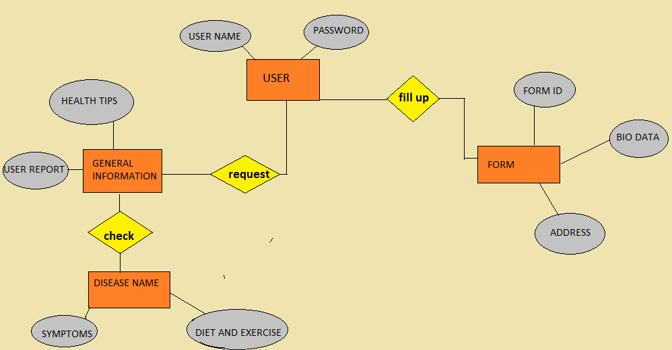

[Figure 1.1]

* 1. **Schema definition:**

Modules that will be there in the projects are:

* Admin:
* Login
* Manage User
* View who register

* User:
* Registration
* Login
* Check weight
* Check dieses
* Views exercises
* Views diets
* Change details
  1. **Schema Diagram:**

Admin

User

**3.4 System Flow:**

* **DFD:**

**FLOWCHART:**

**ADMIN Flowchart:**

**USER flowchart:**

**CHAPTER 4**

Log out

Yes

User profile

No

If successful

Registration

**SYSTEM IMPLEMENTATION**

**4.1 Database Implementation:**

There are three tables we use in our project. These three tables are given below.

1. cusinfo
2. logininfo
3. Diseasesinfo

In cusinfo table the information about the users is store. In this table along with the user’s information security question and answer are also stores which help at the time of password recovery. Constraint we use in this table is primary key. Here we give primary key to the uid.

Next table is logininfo. In logininfo table information about login of users is store. Information like id, password and type of user is store here. Constraint we use in this table is primary key. Here we give primary key to the uid.

Third table is Diseasesinfo. In Diseasesinfo information related to diseases is stored. Disease information like cause, symptoms and prevention are stored. Constraint used in this table is not null.

* 1. **Table snapshots:**

1. **cusinfo:**

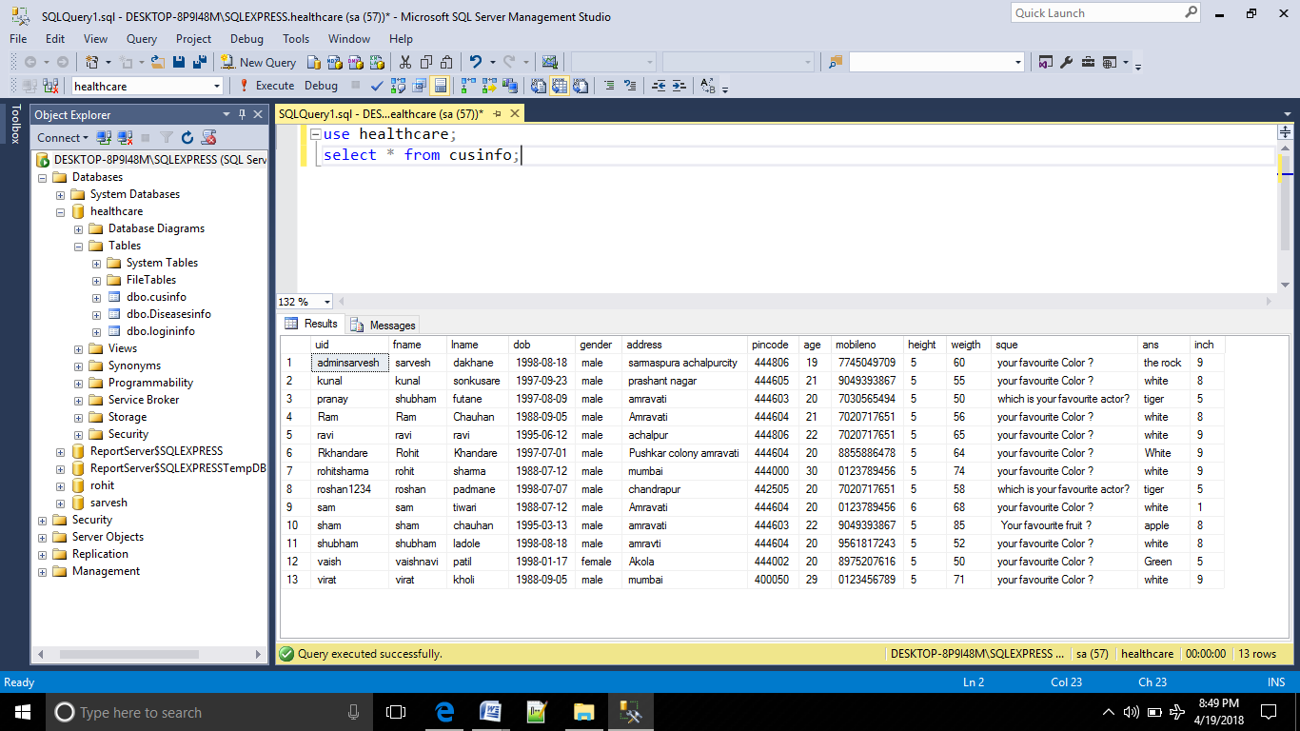

1. **logininfo:**

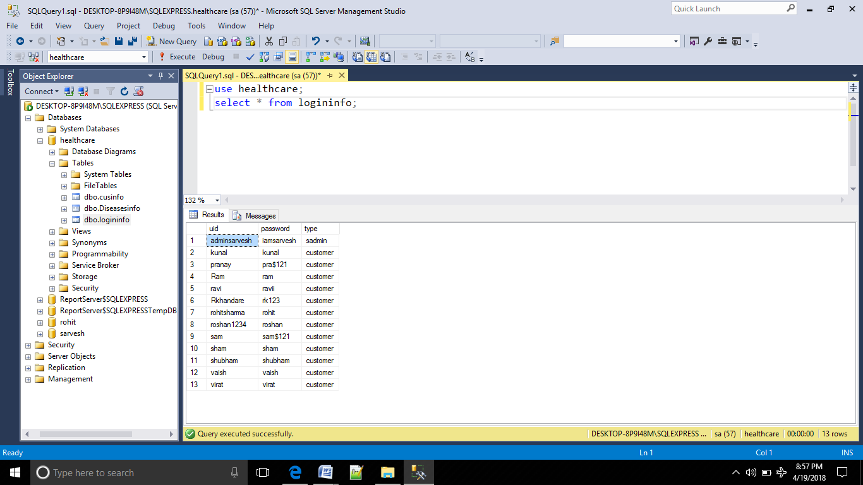

1. **Diseasesinfo:**

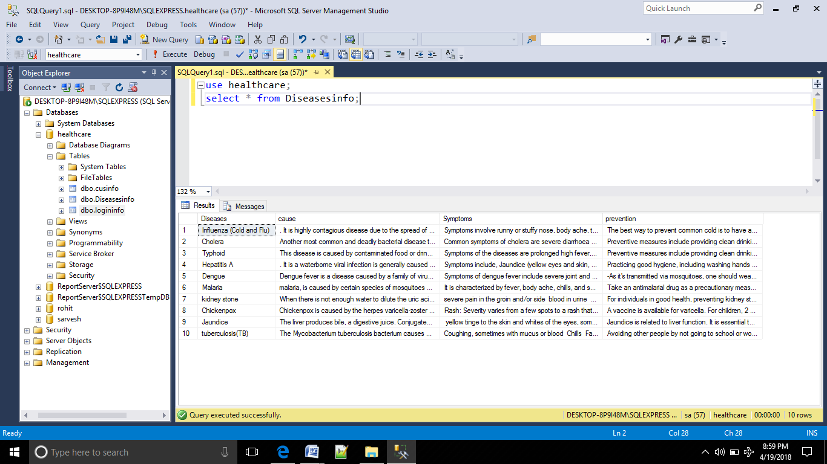

* 1. **System screenshots:**

This is the home page of our website. also login page for user and admin.

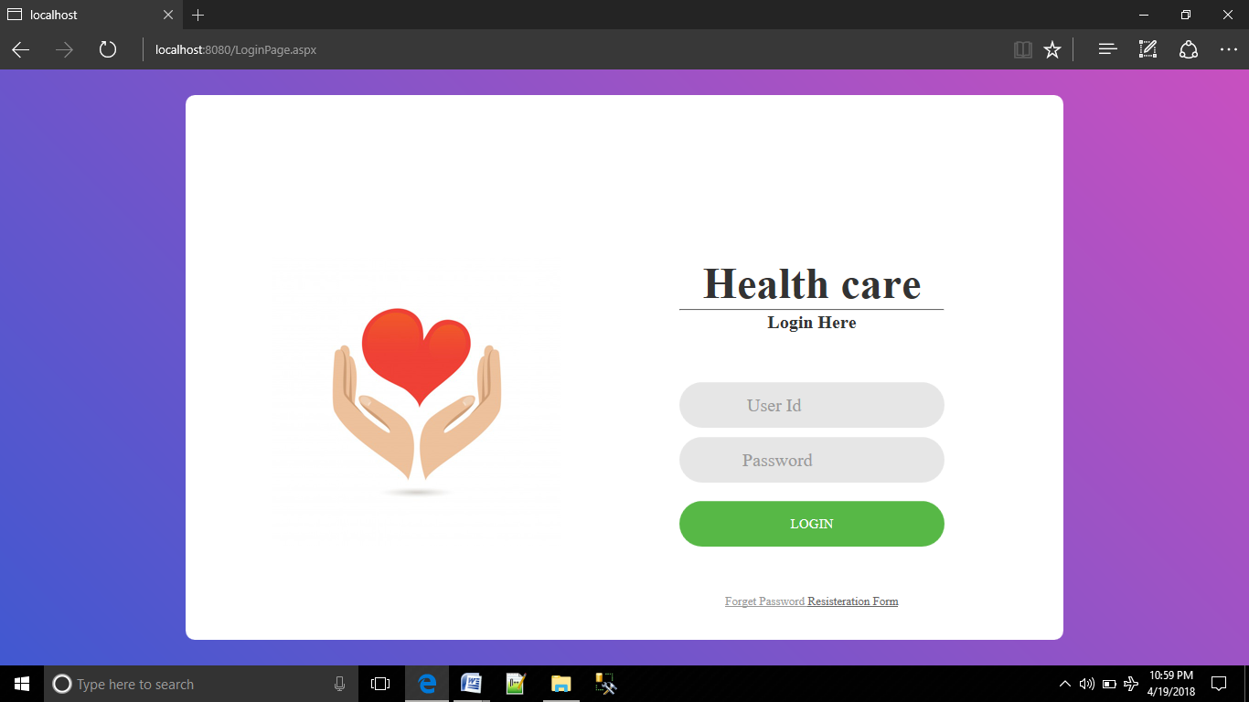

By clicking on the Registration form will get to the registration form for the user which is submitted for creating an account of the user.

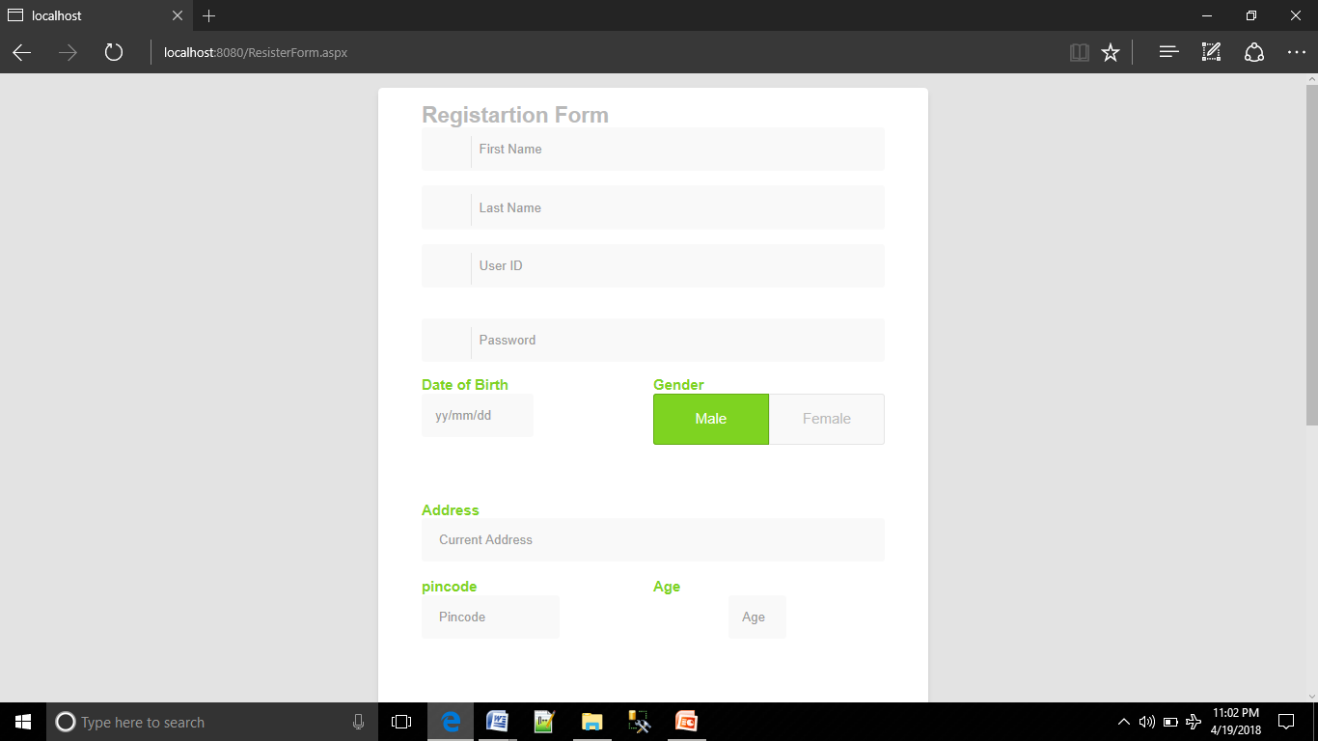

This is the user welcome page after login and contains various tabs as follows.

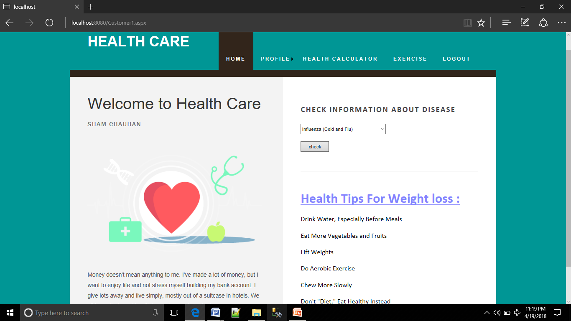

after clicking HEALTH CALCULATOR new tab is open where user check his ideal weight by entering height and age.

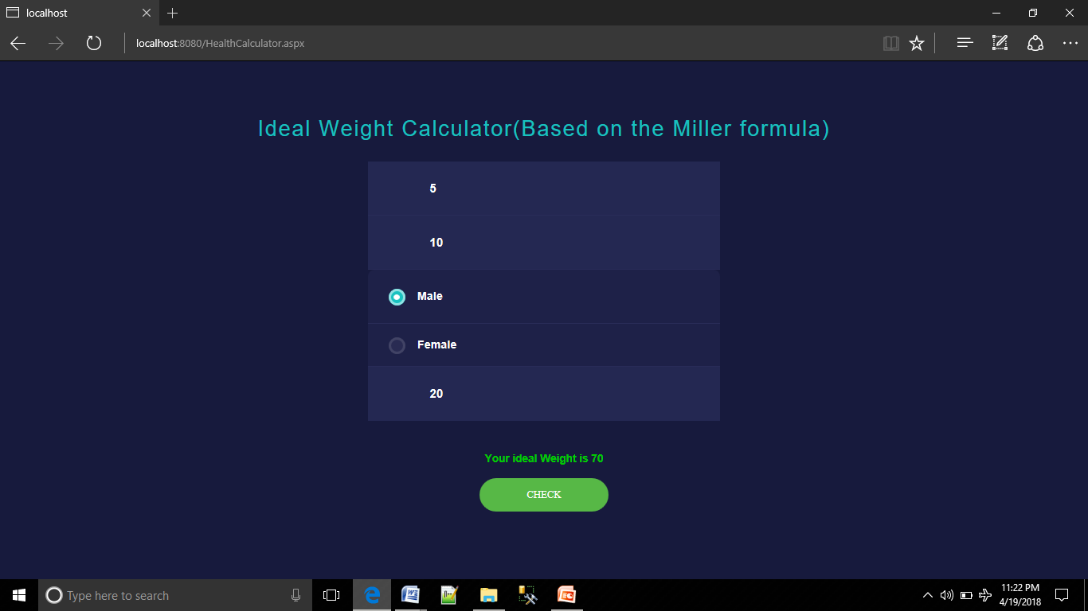

This is the panel which shows user details about exercise by clicking EXERCISE.

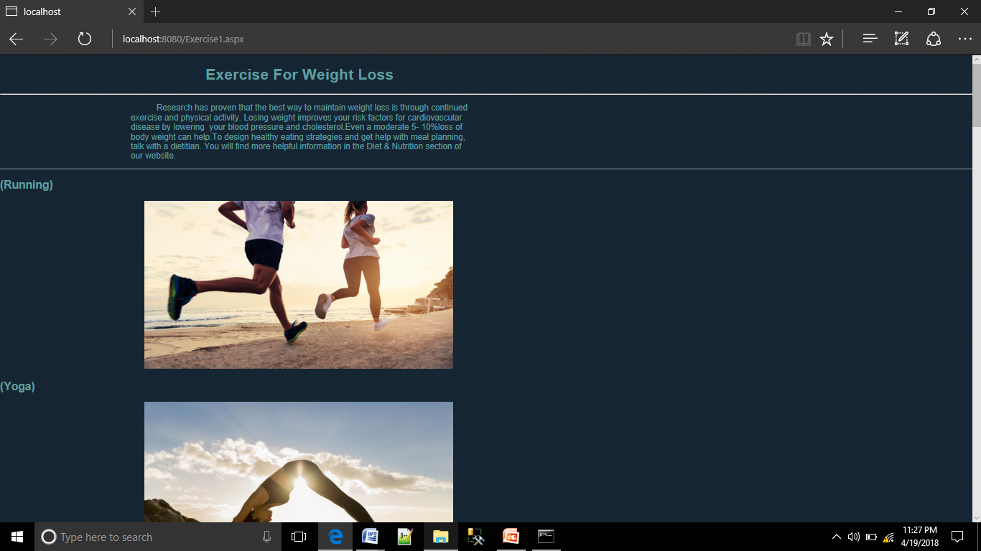

On same panel diets are also shown.

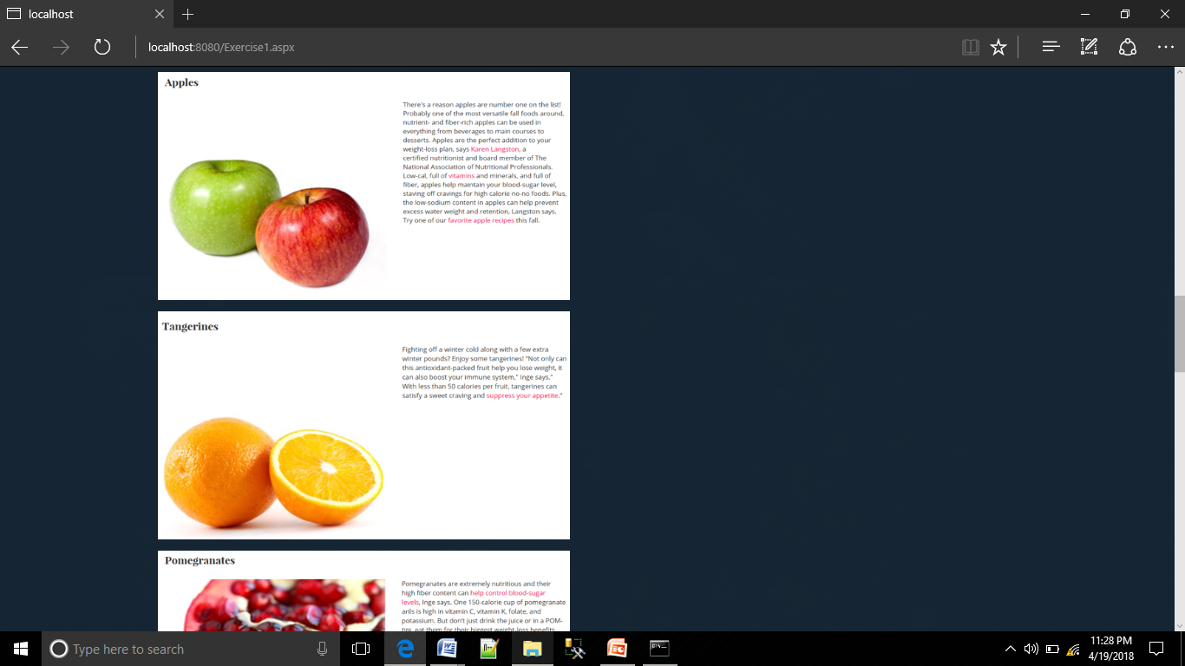

After clicking PERSONAL INFO update information panel is open.

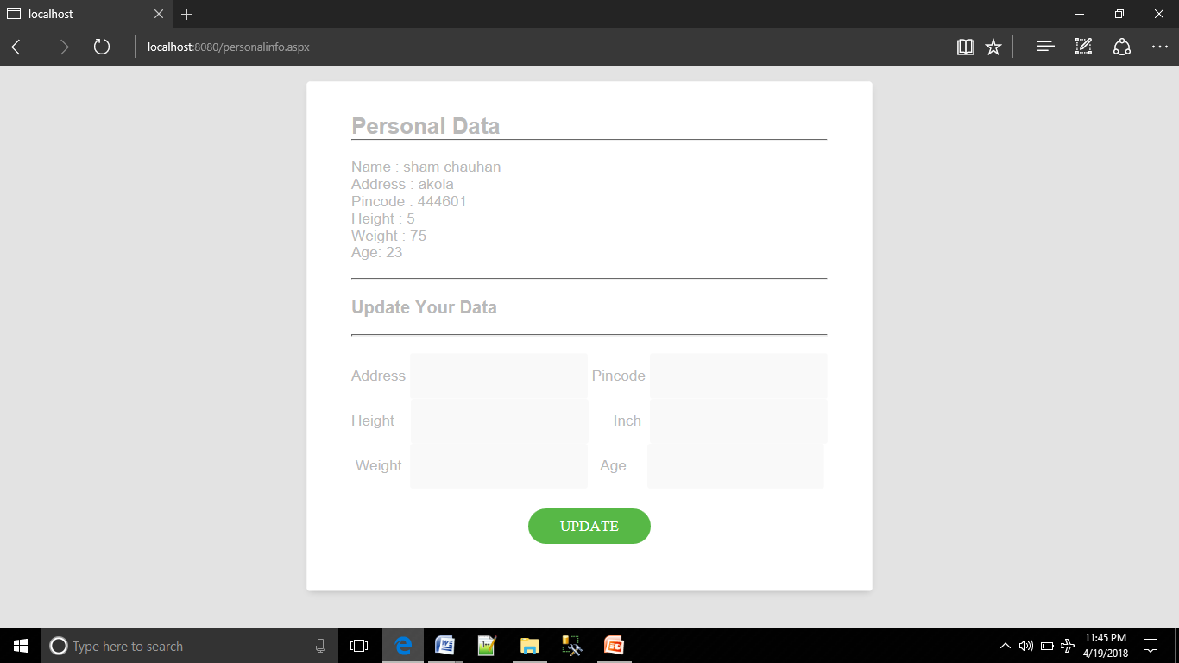

If user wants to change password then select CHANGE PASSWORD then following panel is open.

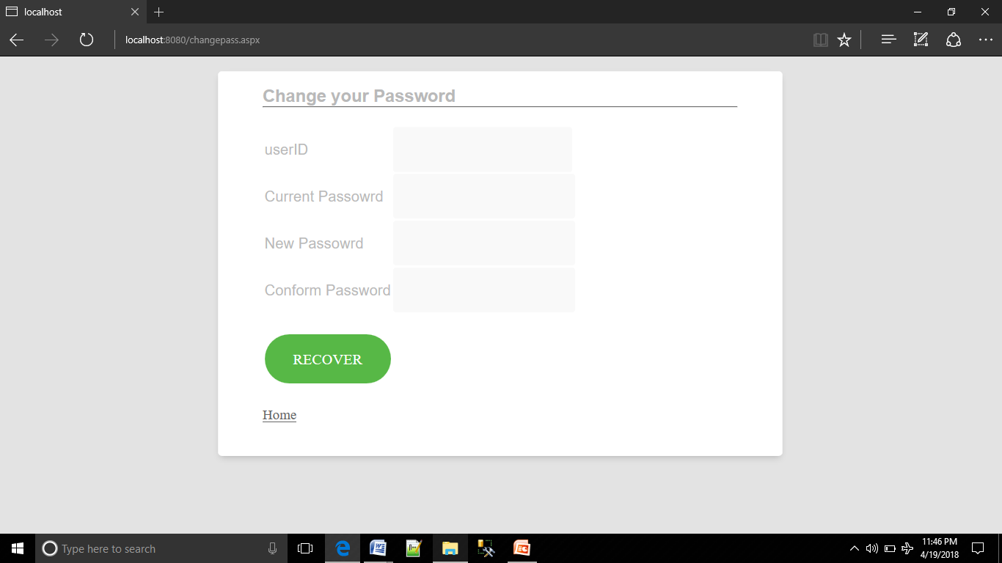

If user forgot password then click on Forgot Password.

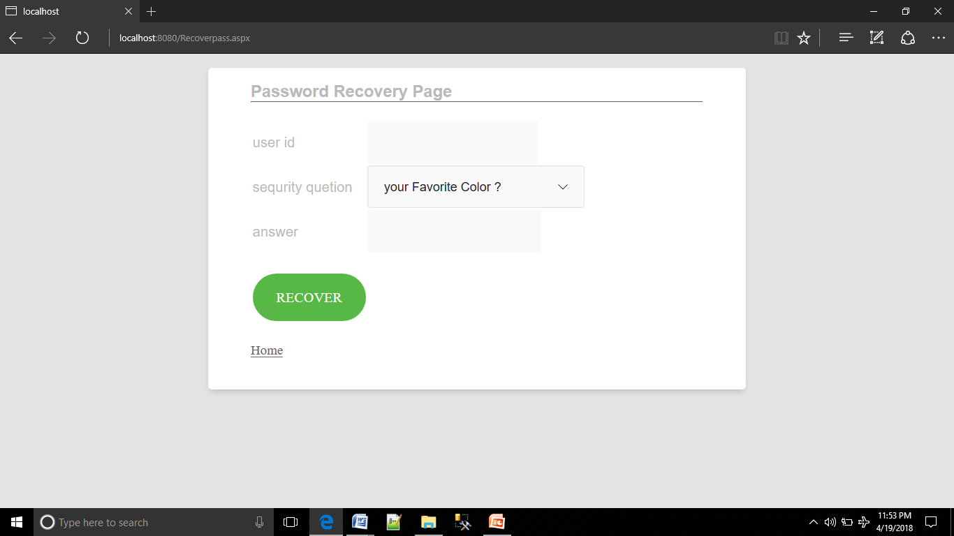

**2. Admin module:**

Admin can login in from home page as shown in following panel.

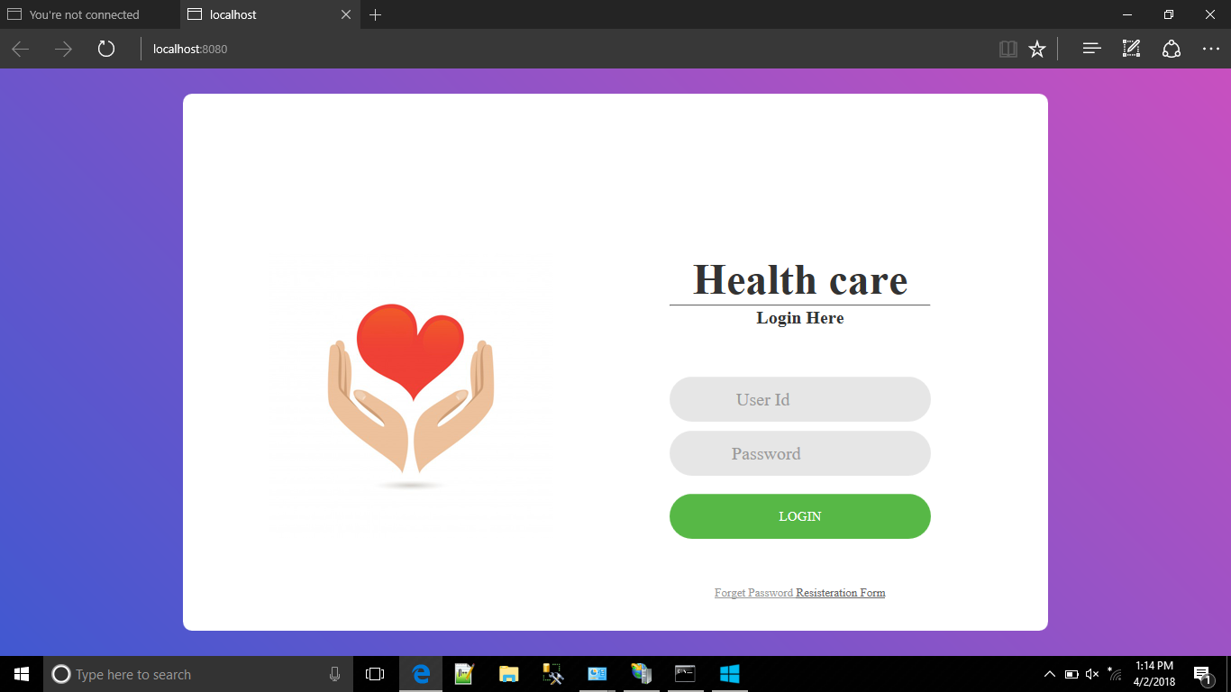

After admin successfully login in admin panel is open.

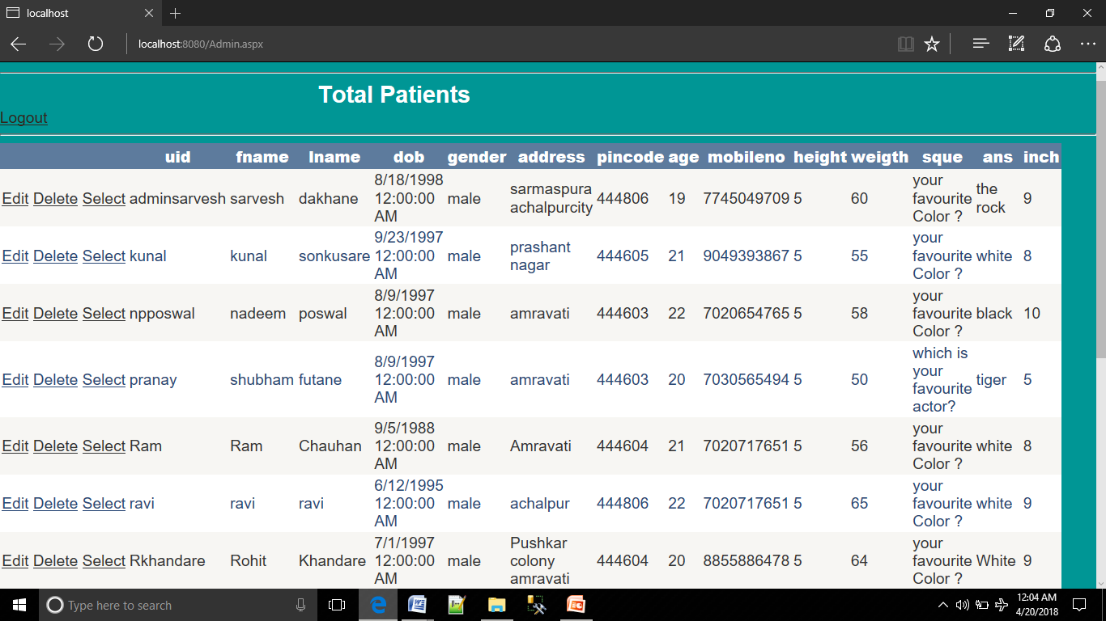

**CHAPTER 5**

**Conclusion:**

1. We had developed a website which is useful for user to maintain their health naturally with the help of exercises and diet.
2. Minimizing human effort and cost efficient databases.
3. Navigation through the site is easy.
4. We conclude that our website is too much helpful to the user who have health problem due to weight.

**Future Scope:**

1. In future we will give the facility for personal exercise arrangement.
2. We will include more functionality as per user requirements.
3. We want to improve our home page as it is the main thing which attracts user.
4. Higher security features can be added.
5. Reusability of this website is also possible.
6. In future we will also provide facility for doctor services.
7. More diseases will be added.

**Reference**

* Miller Formula- <http://www.bmi-calculator.net/ideal-weight-calculator/miller-formula/>
* CSS Code - <http://www.littlewebhut.com/css/>
* Disease Information - <https://www.cdc.gov/diseasesconditions/index.html>
* Google Map - <https://developers.google.com/maps/>
* Exercise and Diet - <https://www.thefiteindian.com/>
* Html tags : <https://www.w3schools.com/html/default.asp>